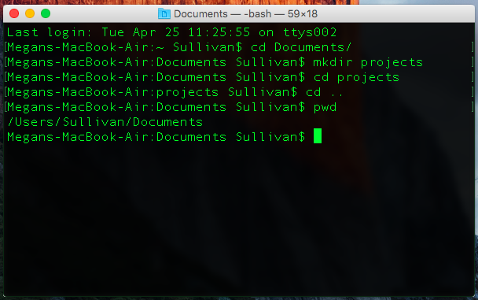

## OVERVIEW

You will learn how to manipulate your computer using text-based commands. To do this, you will use something called a command-line interface (called Terminal on Mac, or Command Prompt on Windows). A command-line interface is an old tool created before computers had graphical interfaces like icons that you can double click on to start a program. Programmers continue to use this interface because it runs faster and makes certain tasks easier -- like running the same command on multiple files (remember loops?).

You will also learn your first Python commands! Using the Python interpreter, a program you can run using the command-line interface, you will explore some python commands. The python interpreter is used by programmers when they want to quickly test the output of certain commands.

By the end of this project, you will know how to:

* Use the terminal to navigate folders
* Use the python interpreter to run commands

## INSTRUCTIONS

**Part 1: The Command-line Interface**

First, we’ll start by opening our command line tool and trying out some commands to navigate folders.

Steps:

1. Open the command line tool on your computer.
   1. On Mac machines, open the Terminal application.
   2. On Windows machines, open the Command Prompt application.
2. Create the sample folder structure from the reference.
3. Test out the commands on the folder structure and fill out the worksheet for the **Command Line Commands**.

**COMMAND LINE COMMANDS**

|  |  |  |
| --- | --- | --- |
| **Command**  what you type in and press enter  (things in [] should be replaced by you) | **Output**  what displays after you hit enter (if anything) | **What It Does**  In your own words, what the command does |
| Mac:  pwd  Windows:  cd |  |  |
| cd [foldername] |  |  |
| cd .. |  |  |
| Mac:  ls  Windows:  dir |  |  |
| Mac:  python3  Windows:  python |  |  |

**Part 2: The Python Interpreter**

After we run the appropriate python command to start the interpreter, we’re going to explore some Python commands. The Python Interpreter will run each command and tell you the result; your goal is to figure out what the command does based on the answer.

Steps:

1. Start the Python interpreter in your command line interface.
   1. On Mac machines, python3.
   2. On Windows machines, python.
2. Fill out the worksheet below for the **Python Interpreter Commands**.
3. Use the extra space in each part to try out more related commands. Look them up or try making up commands that you think might exist.

**PYTHON INTERPRETER COMMANDS PT 1**

|  |  |  |
| --- | --- | --- |
| **Command** | **Output** | **What It Does** |
| 14 + 1 |  |  |
| "apple" + "banana" |  |
| "25" + 16 |  |
| 6 / 3 |  |  |
| 5 / 3 |  |
| 5 // 3 |  |  |
| 9 % 3 |  |  |
| 8 % 3 |  |
| 7 % 3 |  |
| 6 % 3 |  |
| 10 * 4 |  |  |
| 10 ** 4 |  |  |
|  |  |  |
|
|  |  |  |
|
|  |  |  |
|
|  |  |  |
|
|  |  |  |
|

**PYTHON INTERPRETER COMMANDS PT 2**

|  |  |  |
| --- | --- | --- |
| 5 == 5 |  |  |
| "5" == 5 |  |
| 5 == 12 |  |
| 3 != 3 |  |  |
| "3" != 3 |  |
| 26 != 7 |  |
| 16 < 3 |  |  |
| 4 < 4 |  |
| 2 < 9 |  |
| 25 > 8 |  |  |
| 12 > 12 |  |
| 5 > 29 |  |
|  |  |  |
|
|  |  |  |
|
|  |  |  |
|
|  |  |  |
|
|  |  |  |
|

**PYTHON INTERPRETER COMMANDS PT 3**

|  |  |  |
| --- | --- | --- |
| True and True |  |  |
| True and False |  |
| False and True |  |
| False and False |  |
| True or True |  |  |
| True or False |  |
| False or True |  |
| False or False |  |
| not False |  |  |
| not True |  |
| exit() |  |  |
|  |  |  |
|
|  |  |  |
|
|  |  |  |
|
|  |  |  |
|
|  |  |  |
|
|  |  |  |
|

### 

### 

### **REFERENCE**

**Sample Folder / Directory Structure**

* Here’s an example of a directory structure.

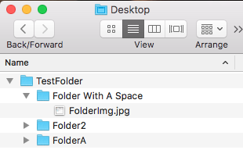

* This TestFolder is located in the Desktop directory. This makes the Desktop the **parent** of TestFolder and the TestFolder the **child** of the Desktop.



* Directory structures come in layers. Here’s the next layer down! Now, TestFolder is the parent, and the three folders that it has are the children.



**Here are some common folder / directory commands:**

**pwd (mac) / cd (windows)**

* The print working directory command tells you the file path to the folder you are in (i.e. all of the parents and the current folder)
* If we called pwd while in FolderA, we might see:
  + Users/[username]/Desktop/TestFolder/FolderA

**cd [directorypath]**

* Changes the current directory to the directory specified.
* From anywhere, to get to Folder2, we might call:
  + cd Users/[username]/Desktop/TestFolder/Folder2
* From TestFolder, we would just call:
  + cd Folder2

**..**

* Placeholder for the current folder’s parent directory. For example, if you wanted to change to the current folder’s parent directory, you would type:  
  cd ..
* To go from FolderA back to TestFolder, we could call:
  + cd ..
* To go from Folder2 to FolderA, we can call:
  + cd ../FolderA

**ls (Mac) / dir (Windows)**

* Lists all the files in the current directory.
* Calling ls after navigating to “Folder With A Space”, we would see the list:
  + FolderImg.jpg

**python3 (Mac) / python (Windows)**

* Opens the Python interpreter.